Code No.: | HTU/P10 | Date Established | 9/11/2017
Responsible  Department | University Services & Project Management Department | Date Posted | 9/11/2017
Responsible Executive | University Services Department and Deanship of the programmes | Date Last Revised  Revision # 4 | 11/11/2024
Quality Nominee | Rumiana Bahova Nuseibeh | Forward Revision date | 11/11/2025

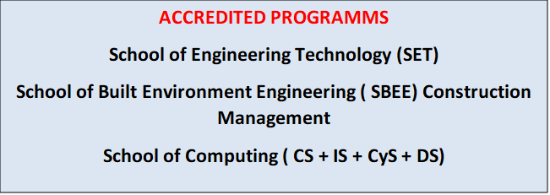

This Document was last revised : 11th November 2024

Risk Assessment, Health and Safety Policy

- DEFINITIONS

- Risk assessment: A structured and systematic procedure for identifying hazards and evaluating risks in order to prioritise decisions to reduce risks to an acceptable level.
- Hazard: Something with the inherent ‘potential to cause harm’. This can include substances, machines, and methods of work or work organisation.
- Risk: Is the chance, great or small, that someone will be harmed by the hazard. The magnitude/scale of the risk is measured in terms of its consequences, frequency and severity

- RESPONSIBILITY

- HTU is committed to ensuring the health, safety and welfare of its employees and students, and it will, so far as is reasonably practicable, establish procedures and systems necessary to implement this commitment and to comply with its statutory obligations on health and safety. It is the responsibility of each employee and student to familiarise themselves and comply with HTU’s procedures and systems on health and safety.
- While HTU will take all reasonable steps to ensure the health and safety of its employee and students, health and safety at work is also the responsibility of the employees and students themselves. It is the duty of each employee and student to take reasonable care of their own and other people’s health, safety and welfare and to report any situation which may pose a serious or imminent threat to themselves or of any other person. If an employee or a student is unsure how to perform a certain task or feels it would be dangerous to perform a specific job or use specific equipment, then it is the employee’s and student’s duty to report this as soon as possible to their line manager, their health and safety representative or the safety officer. Alternatively, an employee or a student may, if they prefer, invoke HTU’s formal grievance procedure or they may make a complaint under HTU’s provisions on Disclosures in the Public Interest.
- During the Coronavirus Pandemic (COVID-19), HTU complied fully with the Government’s defence orders, health and safety measures and lockdowns.
- Disciplinary action under HTU’s disciplinary procedure may be taken against any employee and student who violates health and safety rules and procedures or who fails to perform their duties under health and safety legislation. Depending on the seriousness of the offence, it may amount to potential gross misconduct rendering the employee and student liable to summary dismissal.
- HTU will provide and maintain a healthy and safe working environment with the objective of minimising the number of instances of occupational accidents and illnesses.

HTU will pay particular attention to:

- Maintaining the workplace in a safe condition and providing adequate facilities and arrangements for welfare at work.
- Providing a safe means of access to and egress from the workplace.
- The provision and maintenance of equipment and systems of work that are safe.
- Arrangements for ensuring safety to health in connection with the use, handling, storage and transport of articles and substances.
- The provision of such information, instructions, training and supervision as is necessary to ensure the health and safety at work of its employees and students and other persons.

- HTU also recognises its duty to protect the health and safety of all visitors to HTU, including contractors and temporary workers, as well as any members of the public who might be affected by HTU’s work operations.

- HTU University

- HTU President has overall responsibility for health and safety at HTU. The safety officer has responsibility for overseeing, implementing and monitoring health and safety procedures in HTU and for reporting back to the Board on health and safety matters. The safety officer also conducts regular inspections of the workplace, maintains safety records and investigates and reports on accidents at work.

- Training

- Safety training is an integral part of an effective health and safety programme. It is essential that every employee and student is trained to perform their job safely. All employees and students will be trained in safe working practices and procedures.

- Training will include instruction on the safe use of equipment provided.

- Employees and students at special risk

- HTU recognises that some workers may from time to time be at increased risk of injury or ill‐health resulting from work activities. HTU therefore requires that all employees and students advise their line manager if they become aware of any change in their personal circumstances which could result in their being at increased risk. This could include medical conditions, permanent or temporary disability, taking medication and pregnancy.

- First aid and reporting accidents at work

- A First Aid box is located on the main floor. All employees and students will be shown the location of the first aid box and will be given the names of the designated first aid personnel. All injuries, however small, sustained by a person at work must be reported to their line manager or the safety officer and recorded in the accident book. Accident records are crucial to the effective monitoring of health and safety procedures and must therefore be accurate and comprehensive. The safety officer will inspect the accident book on a regular basis and all accidents will be investigated and a report prepared, with any necessary action being taken to prevent a recurrence of the problem.

- Fire

- Fire is a significant risk within the workplace. All employees and students have a duty to conduct their operations in such a way as to minimise the risk of fire and they are under a duty to report immediately any fire, smoke or potential fire hazards, such as faulty electric cable or loose connections. Employees and students should never attempt to repair or interfere with electrical equipment or wiring themselves. The safety officer is responsible for the maintenance and testing of fire alarms and fire fighting, prevention and detection equipment.

- Fire extinguishers are located at strategic points throughout the workplace. If fire is discovered, it is the responsibility of any present to help evacuate the building.
- Employees and students are expected to tackle a fire themselves only if it would pose no threat to their personal safety to do so. If the situation is dangerous or potentially dangerous, the employee or student should evacuate the building immediately.
- All employees and students must ensure they are familiar with their evacuation route and designated assembly point in case of fire. Practice fire drills will be conducted on a regular basis to ensure employee and student familiarity with emergency evacuation procedures.

- HTU safety rules

- All employees and students should be aware of and adhere to HTU’s rules and procedures on health and safety
- All employees and students must immediately report any unsafe working practices or conditions to their line manager, their health and safety representative
- Horseplay, practical joking, running in the workplace, misuse of equipment or any other acts which might jeopardise the health and safety of any other person are forbidden
- Any person whose levels of alertness are reduced due to illness or fatigue will not be allowed to work if this might jeopardise the health and safety of any person
- Employees and students must not adjust, move or otherwise tamper with any electrical equipment or machinery in a manner not within the scope of their job duties
- No employee or student should undertake a job which appears to be unsafe
- No employee or student should undertake a job until they have received adequate safety instruction and they are authorised to carry out the task
- All injuries must be reported to the employee’s and student’s line dean or head
- All materials must be properly and safely used and when not in use properly and safely secured
- Work should be well‐planned to avoid injuries in the handling of heavy materials and while using equipment
- Employee and students should take care to ensure that all protective guards and other safety devices are properly fitted and in good working order and must immediately report any defects to their line dean or director
- Suitable clothing and footwear must be worn at all times
- Work stations and work sites must be kept clean and tidy and any spillage must be cleaned up immediately
- Employee and students should use handrails when going up and down stairs, should never read while walking, must close filing cabinet drawers when not in use and must keep all floor areas free of obstruction.

- Access

- Walkways and passageways must be kept clear and free from obstructions at all times
- If a walkway or passageway becomes wet it should be clearly marked with warning signs and any liquid spilt on the floor should be wiped up immediately
- Trailing cables should not be left in any passageway
- Where objects are stored in or around a passageway, care must be taken to ensure that no long or sharp edges jut out into the passageway

- Tools and equipment

- HTU machinery, tools and equipment are only to be used by qualified and authorised personnel
- It is the responsibility of all employee and students to ensure that any tools or equipment they use are in a good and safe condition. Any tools or equipment which are defective must be reported to next line manager or to the safety officer
- All tools must be properly and safely stored when not in use
- Approved personal protective equipment must be properly used where appropriate
- Employee and students are prohibited from using any tool or piece of equipment for any purpose other than its intended purpose.

- Manual handling

- Employee and students should not attempt to lift or move a load which is too heavy to manage comfortably. Employee and students should ask for assistance if there is any danger of strain
- When lifting an object off the ground, employee and students should assume a squatting position, keeping the back straight. The load should be lifted by straightening the knees, not the back
- Employee and students should not attempt to obtain items from shelves which are beyond their reach. A ladder or stepping stool should be used. Employee and students should not use chairs or any makeshift device for climbing and should never climb up the shelves themselves.
- the load to be lifted or moved must be inspected for sharp edges and wet patches
- the route over which the load is to be lifted should be inspected to ensure it is free of obstructions

- Risk Assessment

- Correctly and accurately identifies a hazard.
- Disregards inconsequential risks and those risks associated with life in general.
- Determines the likelihood of injury or harm arising.
- Quantifies the severity of the consequences and the numbers of people who would be affected.
- Takes into account any existing control measures.
- Identifies any specific legal duty or requirement relating to the hazard.
- Will remain valid for a reasonable period of time.
- Provides sufficient information to enable the Dean/Director/Head to decide upon appropriate control measures, taking into account the latest scientific developments and advances.
- Enables the college to prioritise remedial measures

- Evaluating the risk and setting priorities

- The risk assessment should enable Schools/Services to prioritise remedial measures. In many cases it will be clear that some risks require attention before others. Where there is uncertainty a risk rating may be attributed to each identified hazard. The factors relating to severity and likelihood of harm are given a numerical value and then multiplied together to give a risk rating which can then be used to prioritise remedial actions.

Added after revision 01/12/2021

- As per the Government’s defence order and MOH directives students will return on the bases of blended learning. For practical courses , attendance will be on campus, complying with all safety measures.




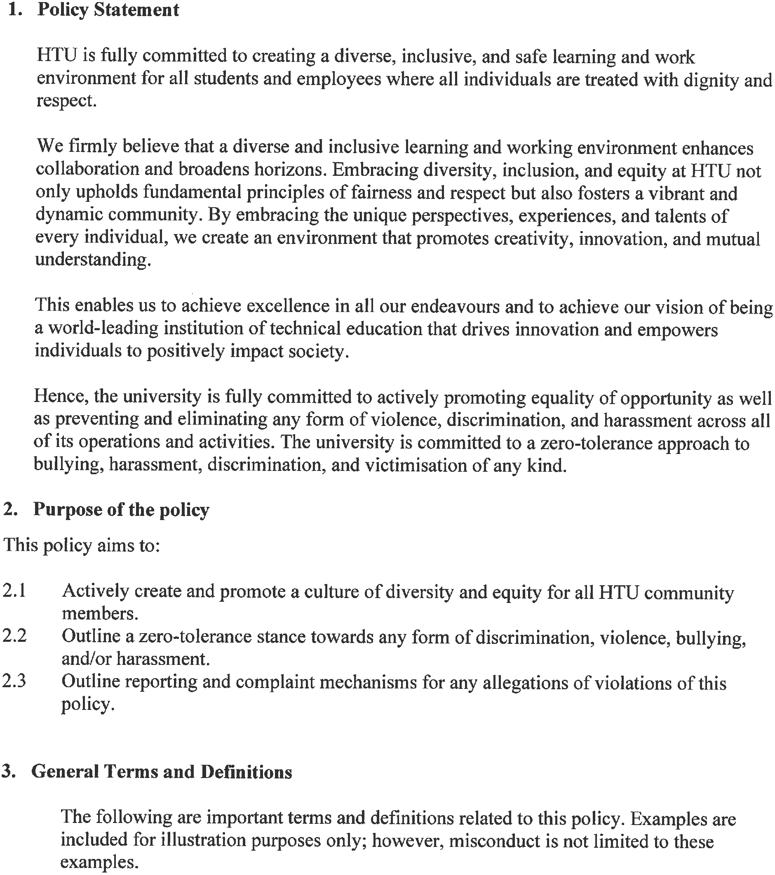




Added after revision 11/11/2024





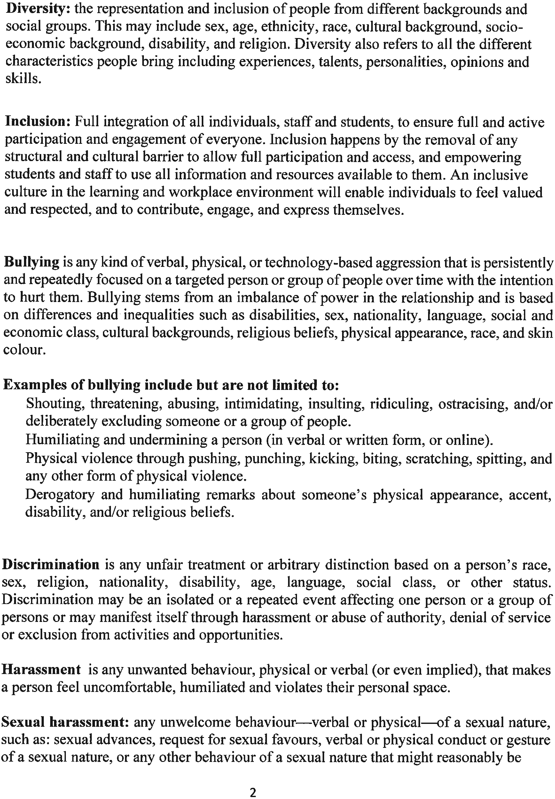







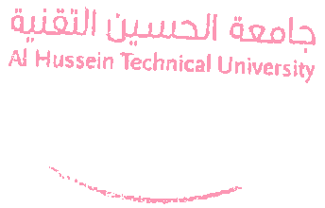

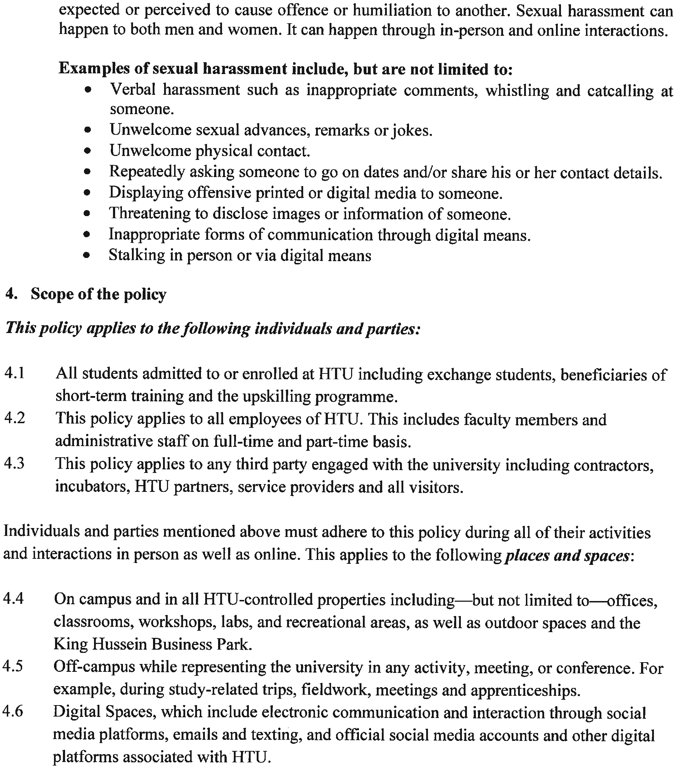




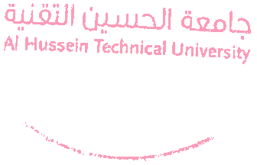
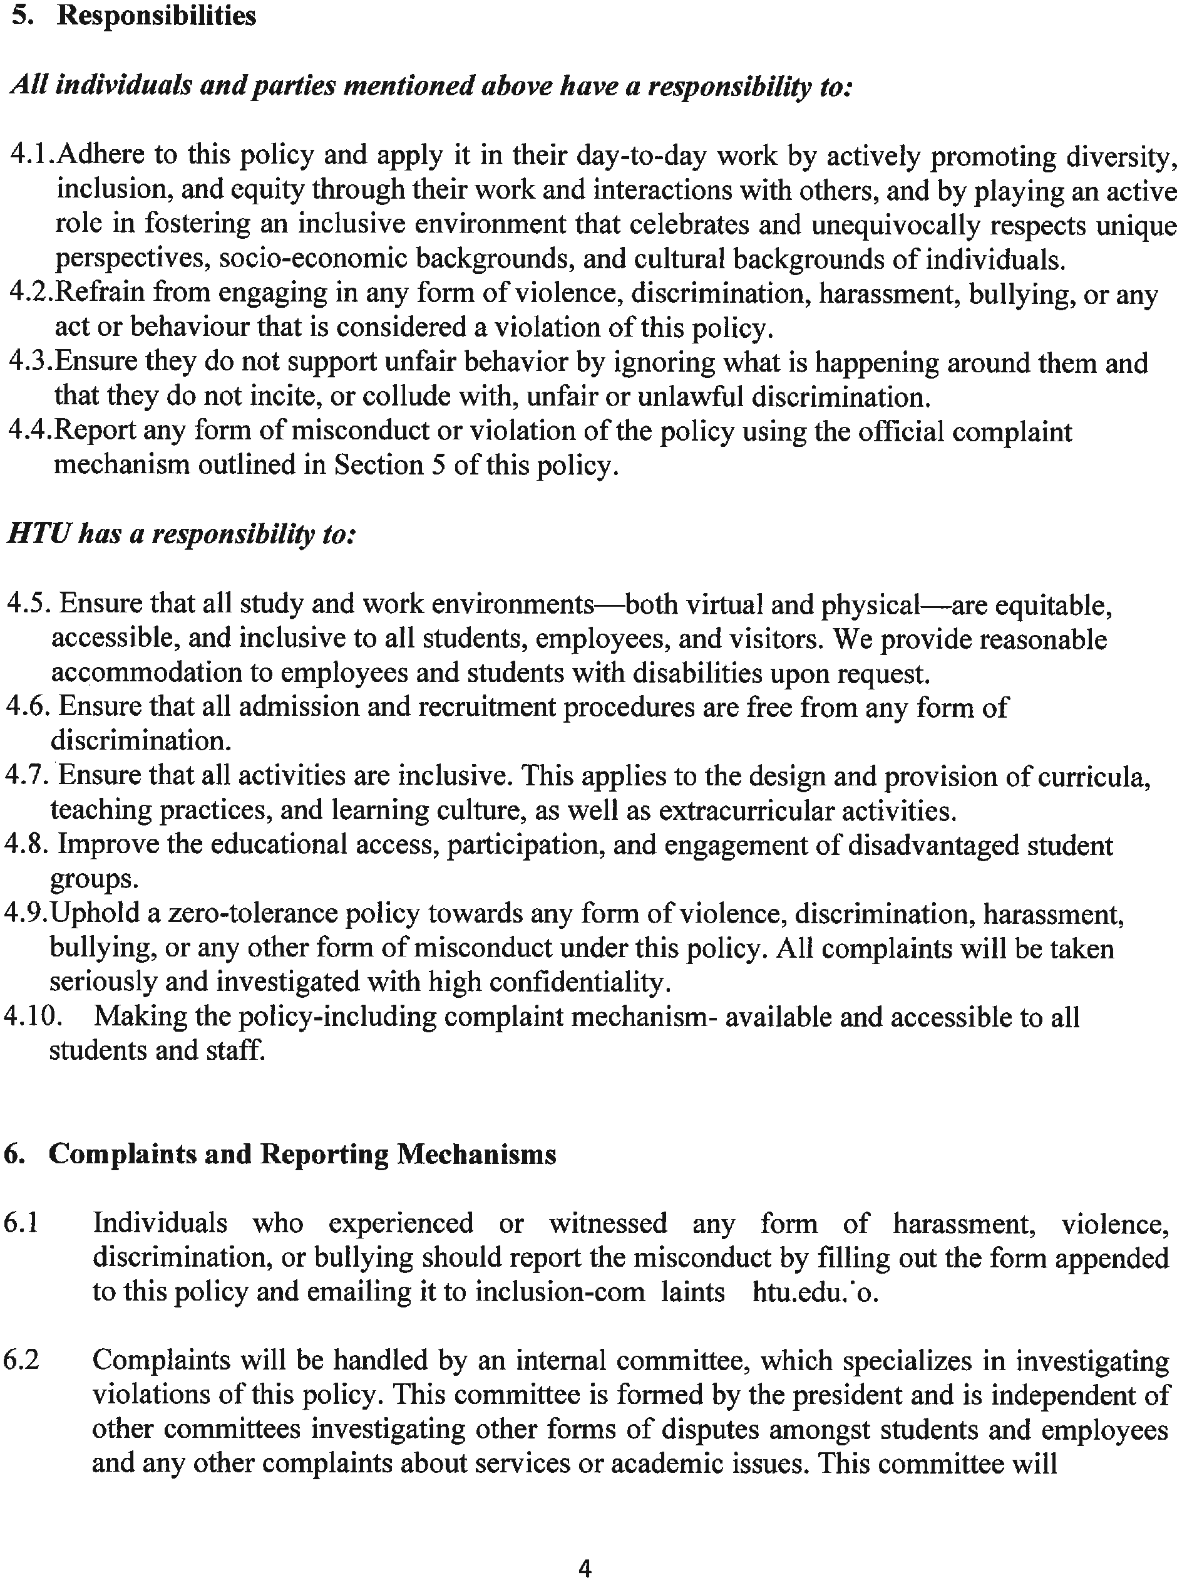






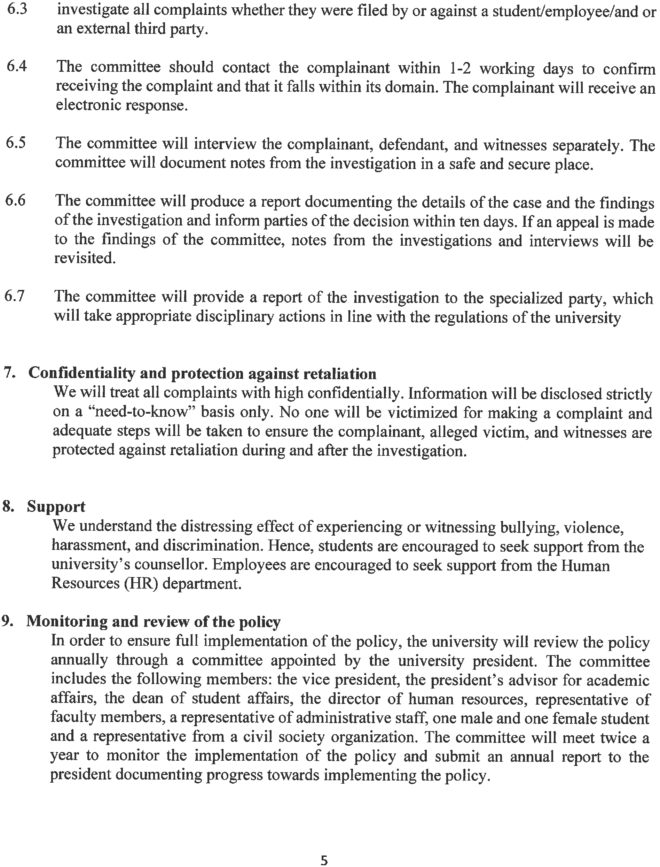


End of Policy.

